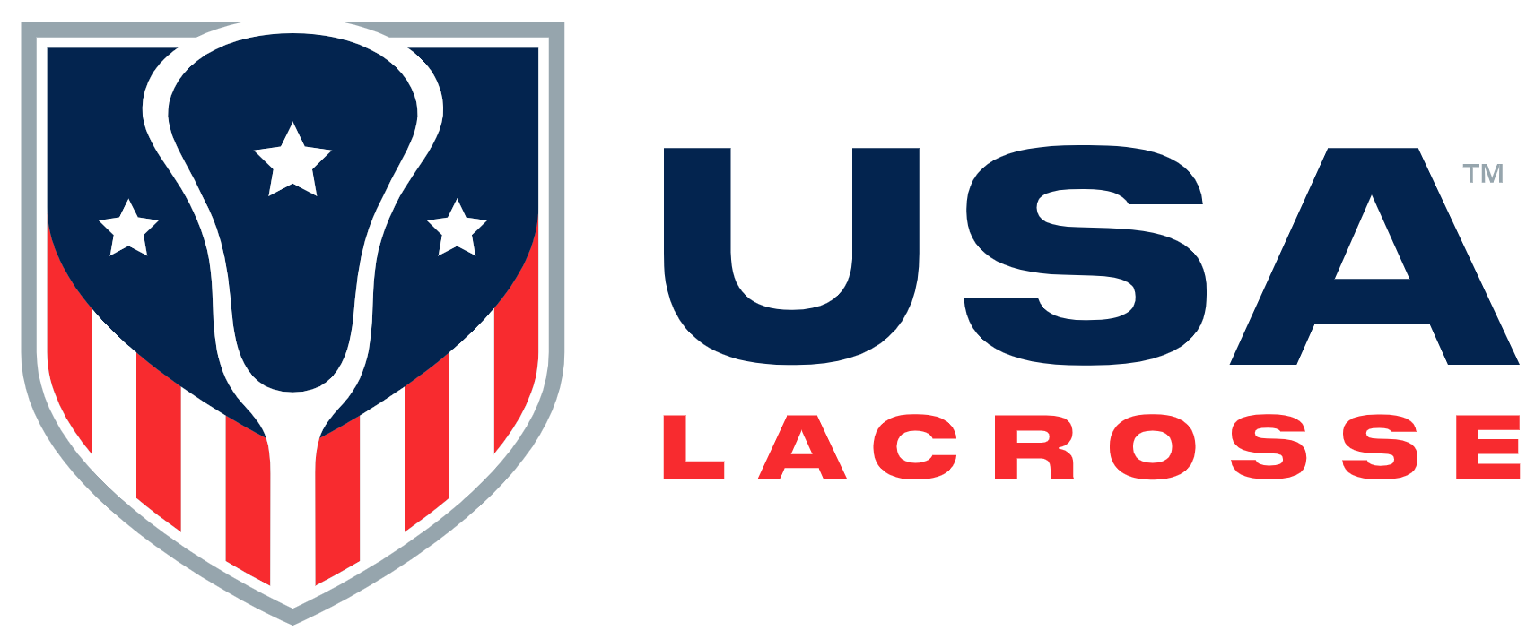

Board Meeting Minutes
Monday, February 23, 2026

Present: Connor Buczek, Alex Cade, Jim Kanuch, Andrew Lee, Andrea Lin, Darren Lowe, Juan-Pablo Mas, Sarah McDaniel, Ann Rodriguez, Jen Russell, and Gina Thomas

Absent: Tim Corrigan, Mike Ehrhardt, Whitney Nye and Brandon Perkins

Staff present: Will Blake, Chris Dax, Caitlin Kelley, Dave Krupinski, Dwane Morgan, Cara Morris, Stephanie Mullette, Nancy Patrick, Larry Quinn, Marc Riccio, Dan Shannon and Jason Vescovi

Guests: CJ Orr and Regina Cialone of The Orr Group

Ms. McDaniel called the meeting to order at 11:03 a.m.

Welcome [S. McDaniel]: Ms. McDaniel welcomed everyone. She stated that the USA Lacrosse Board is now composed of 15 Board members vs 19. This change went into effect on January 1, 2026, and will help USA Lacrosse (USAL) in its efforts with United States Olympic & Paralympic (USOPC) compliance. She welcomed Connor Buczek and Mike Ehrhardt, whose Board service began at the beginning of the year. Mr. Buczek provided his background.

Ms. McDaniel stated the meeting’s main focus would be on the Comprehensive Campaign, including the Board’s role in that; an update on the Membership Product Offering and Digital Revamp; an update on National Teams; Old Business and New Business.

- Consent Agenda [S. McDaniel]: Ms. McDaniel asked if there were any questions. None arose. Mr. Lowe moved to approve the November 2025 Board meeting minutes, the Executive Committee Action List and 2026 meeting calendar; Mr. Mas seconded the motion. The motion was approved.

Conflict of Interest: None raised by Board members. Ms. McDaniel stated Mr. Buczek shared on his submitted Conflict of Interest form that his wife is a member of the Premier Lacrosse League’s Strategic Team but is not aware of any current conflicts. The Governance Committee agrees with Mr. Buczek’s statement but will bring to his attention when/if a conflict does arise.

- Orr Group / Capital Campaign: Mr. Dax welcomed CJ Orr and Regina Cialone of The Orr Group. They have completed a feasibility study for a USAL comprehensive campaign. One goal of the presentation is to identify how the organization can support a campaign effort.
Mr. Orr stated they tested the feasibility via quantitative and qualitative analyses and provided recommendations. He provided details on each analysis. Ms. Cialone and he reviewed a variety of recommendations and strategies for additional preparations and ultimately, success. Discussion ensued.
Mr. Riccio thanked Mr. Orr and Ms. Cialone.

- CEO Update / Wrap Up [M. Riccio]: Report submitted. Mr. Riccio reviewed the five areas in need of support that could resonate in a campaign. It is important to adjust current knowledge to be prepared for the organization in 2028 and beyond.

- Case for Support [M. Riccio]: Report submitted. Mr. Riccio referenced his pre-circulated report. He reviewed:
- A budget snapshot showing the increased investment in National Teams and operating income deficit years
- A U.S. map indicating 24 U.S. states sanction lacrosse and two have some sanctioning recognition
- Five truths about USAL
Mr. Riccio reviewed priority funding areas and related investment outcomes, the pathway to the National Teams, ways to fuel the growth of the game, and resources available to adapt swiftly. He provided a Case for Support Summary draft. Discussion ensued.

- Lunch: There was a break from 12:25 – 12:35 p.m.

- Finance [J. Kanuch / C. Morris]: Report submitted. Ms. Morris stated she would review the 2025 USAL Budget Forecast and would provide a snapshot of the 2026 USAL Operating Budget. The Finance Team is finalizing 2025 fiscal year end audit information. The 2025 audit process will commence in March with newly engaged new audit firm, BDO. Ashley Manion, member of the Data Analytics Team, has been promoted to Director of Finance and there are some additional new members to the team.
Ms. Morris stated that revenues have increased YOY by just under $1M. Ms. Morris reviewed 2025 expense savings.
Ms. Morris reviewed 2026 approved budget revenues and the impact market performance, which is not reflected in the budget, could have.. Ms. Morris stated expenses are projected to increase 5% and USAL is projecting a 2026 net operating surplus. She reviewed the payroll and benefits variance. The biggest risk for the 2026 budget is market performance. Ms. Morris reviewed the potential increase in 2026 payroll and benefits expenses. If USAL’s national governing body application is approved, USAL will be required to use the USOPC background check, which is more expensive. Safe Sport requirements will also increase expenses, as well as any LA28-related costs in 2026.
Ms. Morris will provide an updated 2026 budget forecast at the June Board meeting and will discuss potential adjustments if necessary. Discussion ensued.

- Membership / Digital [S. Mullette / D. Shannon / D. Krupinski]: Report submitted. Mr. Krupinski reviewed the 27-week Digital Experience Redesign timeline. He stated one major change is moving to an action-based navigation system on the usalacrosse.com website. It will be segmented to different audiences and designed for easy use via a mobile phone. The team will create a more cohesive experience and the website will be more modern and streamlined. Mr. Krupinski stated that navigation will be repurposed to be a growth engine for membership.
Ms. Mullette stated part of USAL’s work with contracted company, Siberia, has been redesigning membership products. Internal discussions have focused on what products USAL has, what is valuable to members, and where to invest prior to the launch to ensure a solid core product.
Mr. Morgan stated the team is also researching consumer perception, interest, and overall awareness. The digital roadmap also includes User Interface and User Experience testing, so both digital and core membership product sides obtain feedback prior to the Q3 launch. Mr. Morgan provided some initial feedback.

- National Teams: Dr. Vescovi stated that the USAL High Performance (HP) Department is focused on capturing the gold medal at the 2026 WNT Field World Championship (WC). The roster for that squad was announced in January. This will be the first WC with a roster size of 22 vs. 18 in previous iterations. There are six-to-eight players from the 2022 WNT, six players from the 2024 Women’s U20 NT, and some new faces. There are three continental qualifiers in 2026: Men’s Field in Jamaica, and a combined MNT and WNT Sixes just outside Toronto. The goal of the qualifiers is to secure the U.S. spots in the World Championships and to be in the gold medal games.
Dr. Vescovi stated there is a greater number of international events put on the calendar by World Lacrosse, with the PLL, the WLL and the NLL seasons taking 10 -11 months out of the year. There are some NT athletes who participate on multiple national teams.
The HP Team is focused on elevating the quantity and quality of National Team Development Program (NTDP) players, especially at the Combine events (Stage 2) and ultimately at the Youth Nationals events (Stage 3).
Dr. Vescovi stated the Center’s key priority currently is reigniting the research program. There are two ongoing international projects, one just beginning and one almost finished. There are four to five key priority questions for 2026 and USAL has three external collaborators interested in engaging with USAL. Also, the tactical analytics project that the USOPC is directly funding will provide USAL with a competitive advantage for the Sixes discipline as LA28 approaches. USAL will have more insights into the Sixes game.
Dr. Vescovi reviewed the amount of HP Department activity, specifically related to the NT and NTDP. In 2017, USAL staged four to five NT camps and participated in one World Championship. USAL currently has eight NTs, six Youth National Teams, and four teams competing internationally in 2026.
Dr. Vescovi reviewed NT costs projected for 2026, 2027 and 2028, and stated the U.S. NTs should spend more time together prior to competing. Discussion ensued.

- Business Dashboards: Reports submitted. No questions arose.

- Old Business: No items were discussed.

- New Business
- National Volunteer Applicant: Ms. McDaniel stated Ms. Kelley had put forth Josh McCrain to serve on the Men’s Rules Subcommittee. Mr. Lowe moved to approve the motion; Mr. Lee seconded the motion. The motion was approved.
- USOPC Updates: Mr. Riccio stated the USOPC Board will vote on USA Lacrosse’s National Governing Body application in early April. He stated Ms. McDaniel, Mr. Lee, and Ms. Thomas are working on the creation of USAL’s Athlete Advisory Council. Ms. Morris is leading USA Lacrosse’s SafeSport onboarding.
- Governance Committee Updates: Mr. Lee thanked Mr. Kanuch for his continued service. He provided updates on the national search for a Board Treasurer.
- June 2026 Board Meeting: Ms. McDaniel stated the next meeting will be in NYC on Thursday, June 4th in conjunction with the 2026 USAL Foundation Gala. Ms. Patrick will send an email with details in the near future.

- Executive Session: Staff other than Mr. Riccio exited at 1:43 p.m.

- Adjournment: The meeting adjourned at 2:30 p.m.

The Executive Committee approved the following:
- The Consent Agenda, which included the November 2025 Board meeting minutes, 2026 USAL/USALF Meeting and Event calendar and Executive Committee actions since the last Board meeting
- The nomination of Josh McCrain to serve on the Men’s Rules Subcommittee

Action Items Assigned:
- Ms. Morris will provide an updated 2026 budget forecast at the June Board meeting and will discuss potential budget adjustments if necessary
- Ms. Patrick will circulate June 4th Board meeting details in the near future.

There will be an in-person Board meeting from 12:30 p.m. – 4:15 p.m., ET, on Thursday, June 4, 2026, at Jay Conference Suites, Bryant Park, in New York City

