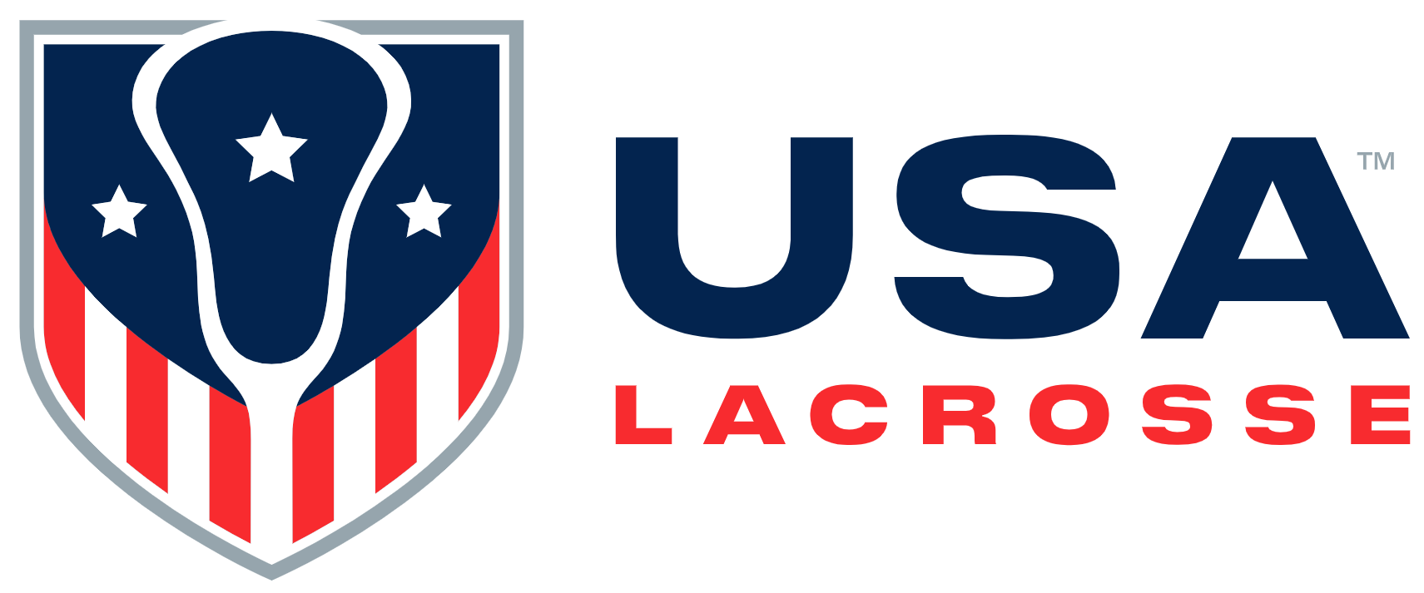

Board Meeting Minutes
Monday, February 17, 2025

Participants: Rick Burton, Alex Cade, Kristen Carr, Fielding Jamieson, Jim Kanuch, Andrew Lee, Andrea Lin, Darren Lowe, Juan-Pablo Mas, Sarah Bullard McDaniel, Shawn Nadelen, Mikko Red Arrow, and Jen Russell

Staff participants: Will Blake, Caitlin Kelley, Cara Morris, Nancy Patrick, Marc Riccio, Dan Shannon, Jason Vescovi and Ellen Zavian

Absent: Tim Corrigan, Whitney Nye, Brandon Perkins, Ann Rodriguez and Gina Thomas

Ms. McDaniel called the meeting to order at 11:03 a.m.

Welcome [S. McDaniel]: Ms. McDaniel welcomed attendees. She asked if any Board members had a conflict of interest with agenda items. None were disclosed.

Ms. McDaniel stated the February 2026 Board meeting will move forward one week to February 23rd to avoid conflicts with the Presidents’ Day holiday weekend. Ms. Patrick will circulate an updated calendar.
Ms. McDaniel asked Mr. Riccio to introduce new Leadership Team (LT) members. Mr. Riccio welcomed Chris Dax, VP of Philanthropy; Dan Shannon, recent addition to the LT as VP of IT – has worked at USAL for ten years; and Caitlin Kelley, recent addition to the LT as Senior Director of Sports Administration – has worked at USAL for ten years.
Ms. McDaniel formally introduced newer Board member Jen Russell, who was unavailable to attend the November 2024 Board meeting.
Ms. McDaniel stated key agenda areas would be a financial overview, business dashboards, USAL’s DEIO approach, NGB application status and process updates, Governance Committee preparations for joining the USOPC, and an update on the Lacrosse Equipment Council (LEC)

- Consent Agenda [S. McDaniel]: Ms. McDaniel stated the Consent Agenda consisted of the November 2024 Board meeting minutes, Executive Committee Action Items since the November 2024 Board meeting, and the 2025 USAL/USALF meeting and event calendar. Mr. Lowe moved to approve the Consent Agenda; Mr. Burton seconded the motion. The motion was approved.
Mr. Riccio asked if there were questions on the CEO Executive Summary. None arose.

- Finance / Business [J. Kanuch/C. Morris]: Report submitted. Ms. Morris asked if there were any questions on the submitted Balance Sheet, Income Statement or financials. None arose. Ms. Morris provided some Finance Department updates:
  - The annual audit will begin in March
  - Staff is closing out 2024 financials
  - 2024 areas still open are:
    - Deferred revenues
    - Merchandise and Inventory
Mr. Kanuch stated USAL has a strong standing from an accounting perspective. Given the projected increase in philanthropic and commercial revenues and the increase in membership dues, Mr. Kanuch could not identify any negative budgetary concerns going into 2025.

- Business Dashboard Discussion [All]: Reports submitted.
- Membership: Mr. Riccio stated 2024 membership transactions were budgeted for 420K; the actual number was 415K. The budgeted revenue was $16M; the actual number was $15.6M. The revenue increase was 15.25% YOY. Mr. Riccio will share USAL’s focus groups research with Board members. Mr. Riccio stated USAL’s January membership transactions are up 2.4% YOY.
- Foundation: Mr. Dax stated the Foundation’s January revenues are up YOY to 2024 and 2023. Curated events in Q4 2024 in Boston and New York City, hosted by Foundation Board members and attended by NT coaches and players, created excitement around organizational work and resulted in financial support of that. He reviewed the revenue goal for the 2025 Gala and efforts to bolster that. Mr. Dax reported on his current review of the Foundation Department and the team’s work in the near future.
- Commercial: Mr. Blake shared current activity in the Retail and Events Departments, which are works in progress Sponsorship is 68% to the 2025 goal, pending a specific contract. Active negotiations and working conversations are in play with multiple potential sponsors. Discussion ensued.

- Lunch: 12:34 – 12:42 p.m.

- New Business
- Transgender / DEIO Update: Mr. Riccio stated USAL’s transgender best practices consist of two parts: participation, for ages 18 and under, and high performance, as it relates to the U.S. National Teams. State laws rule the participatory aspect. USA Lacrosse supports making the sport inclusive for all. Therefore, a player can play on a team designated for the gender with which they identify, subject to state laws. Mr. Riccio stated there is a different level of accountability relative to transgender policies in international competitions for all sports. Dr. Vescovi, Ms. Kelley and others are drafting USAL’s updated transgender policy for NT players, based in best practices using data and science, and working with members of USAL’s Sports Science & Safety Subcommittee and experts in the field. Discussion ensued.
- USOPC Compliance / Governance Committee (GC) Update: Mr. Riccio stated USAL hosted four USOPC governance and high performance compliance representatives on January 28th. Mr. Lee joined the meeting. The USOPC stated USAL is headed in the right direction. Mr. Riccio thanked Ms. Zavian and Ms. Patrick on their efforts. USAL’s NGB application response is 90% complete. Mr. Riccio reviewed the areas that USAL will complete during the next 12 months. USAL will need to formally include elite athletes in specific areas of governance and will comply with Safe Sport background checks and training for staff, volunteers and NT players. Safe Sport background checks cost an additional $10 per person to current charges. Mr. Lee recognized the hard work that Ms. Zavian, Ms. Patrick, Mr. Riccio, Dr. Vescovi and Ms. Kelley continue to do on the NGB process. Fundamentally, USAL is moving from a Recognized Sport Organization (RSO) to a National Governing Body (NGB). Three major changes will occur:
- USAL volunteer groups will be required to have elite athlete representation.
- Safe Sport: More people will be required to be background checked at a deeper level. There are associated costs.
- USAL needs to update its bylaws and operational procedures to be compliant with USOPC standards.
The GC has endorsed three action items in the short term:
- Reduce the number of USAL Board Directors from 19 to 15. This will make the NGB process easier to navigate and will make it clearer for the number of athlete representatives.
- Change the bylaws and operations to modify the Board terms. They currently are August 1 to July 31. The GC suggests moving that to a calendar year, in part because the USOPC requires the athlete representatives on the Board to serve on a calendar year basis. The shift from RSO to NGB could occur on 1/1/2026. The GC has proposed extending the 7/31/2025 Board term end dates to 12/31/2025 for a smooth transition.
- The USOPC requires an NGB’s Board to include 33% elite athlete representation. USAL is in a strong position because it has focused on increasing elite athlete Board representation for the past five years.
The GC is focused on as little disruption as possible to the Board. Mr. Lee stated the current Board is exceptional, partly due to the nature and background of its Directors and the strong culture it has.
The GC seeks Board approval for the following:
- Reduce the size of the Board from 19 to 15 Directors
- Change dates of Board service to a calendar year
- Create an Athlete Advisory Council (AAC). Mr. Lee pointed out that once USAL is an NGB, all current and former elite athletes will have to approve those athletes nominated for Board service. For the short term, the AAC can be as small as three members. The GC recommends Sarah McDaniel, Gina Oliver Thomas and Darren Lowe, which would be ratified by athlete members. This group will become larger with time.
Ms. McDaniel clarified that the proposed AAC nominees would not serve in a long term capacity. The goal would be to replace at least Ms. McDaniel and Mr. Lowe as soon as possible to incorporate broader athlete representation.
The GC moved to reduce the composition of the USAL Board from 19 to 15 Directors; Mr. Mas seconded the motion. The motion was approved.
The GC moved to extend current USAL Board terms from a July 31, 2025 end date to a December 31, 2025 end date; Mr. Kanuch seconded the motion. The motion was approved.
The GC moved to approve Ms. McDaniel, Ms. Thomas and Mr. Lowe to serve as the initial members of the Athlete Advisory Council; Ms. McDaniel and Mr. Lowe recused themselves from this vote. Ms. Carr seconded the motion. The motion was approved.
Mr. Lee thanked Mr. Cade, Dr. Vescovi, Ms. Kelley, Ms. McDaniel and Ms. Patrick for assembling an initial pool of elite athletes for Board service. The GC will ensure Board members have necessary tools to become effective Directors, from Board training to understanding USAL’s culture. Mr. Lowe asked Ms. Carr and Mr. Nadelen, as former NT players/NT coaches and collegiate coaches, to send additional names for that list. Discussion ensued regarding expectations of the AAC and how USAL will communicate with athletes.
- Lacrosse Equipment Council Assessment: Ms. Kelley provided an update on LEC discussion that occurred during the November 2024 Board meeting. Dr. Vescovi, Ms. Kelley and Ms. Zavian suggest creating an external body, as it would provide more legitimacy and incorporate more stakeholder involvement. USAL would invite the NFHS, the NCAA, World Lacrosse and Lacrosse Canada, among others, to join the group. Discussion ensued. Ms. Kelley stated USAL would not benefit monetarily from the Safety Equipment Institute (SEI), a subset of the LEC.
- June Board Meeting Attendance: Ms. McDaniel stated Ms. Patrick would circulate a June 4th Board meeting invitation and ask Directors to respond as soon as possible.

- Old Business:
- Athlete Protection: Mr. Riccio referenced the pre-circulated slides and stated there would be some changes once USAL begins to work with Safe Sport.
- International Lacrosse and Continental Federations: Dr. Vescovi stated World Lacrosse created a new Competitions Committee that will be represented by the four Continental Federations. Ms. Kelley and he submitted their names to represent the Pan American Lacrosse Association (PALA) on said Competitions Committee and await an official response. Ms. Morris stated the PALA Board has approved her nomination for Treasurer. She thanked Ms. McDaniel for her letter of endorsement. Dr. Vescovi stated three PALA Board vacancies are upcoming. He will submit his name for an At-large Board position.

- Executive Session: Staff other than Mr. Riccio exited the room at 1:51 p.m.

- Adjourn: The meeting adjourned at 2:52 p.m.

The Board approved the following:
- The Consent Agenda that included November 2024 Board meeting minutes, Executive Committee Action List and the 2025 USAL/USALF meeting and event schedule
- To decrease the number of USAL Board members from 19 to 15 beginning January 1, 2026
- To lengthen Board terms currently slated to end 7/31/2025 to 12/31/2025 to align with USOPC suggestions
- To nominate Sarah McDaniel, Darren Lowe and Gina Oliver Thomas to serve on USA Lacrosse’s inaugural Athlete Advisory Council
Action Items Assigned:
- Ms. Patrick will circulate an updated 2026 meeting/event calendar
- Ms. Morris will send the 2025 Operating Budget overview slide to Mr. Riccio for circulation to the Board
- Mr. Riccio will share USAL’s focus groups research with Board members.
- Ms. Patrick will circulate a June 4th USAL Board meeting calendar invitation and ask Directors to respond as soon as possible.

There will be an in-person Board meeting in New York City from 12:15 – 4:15pm on Wednesday, June 4th.

