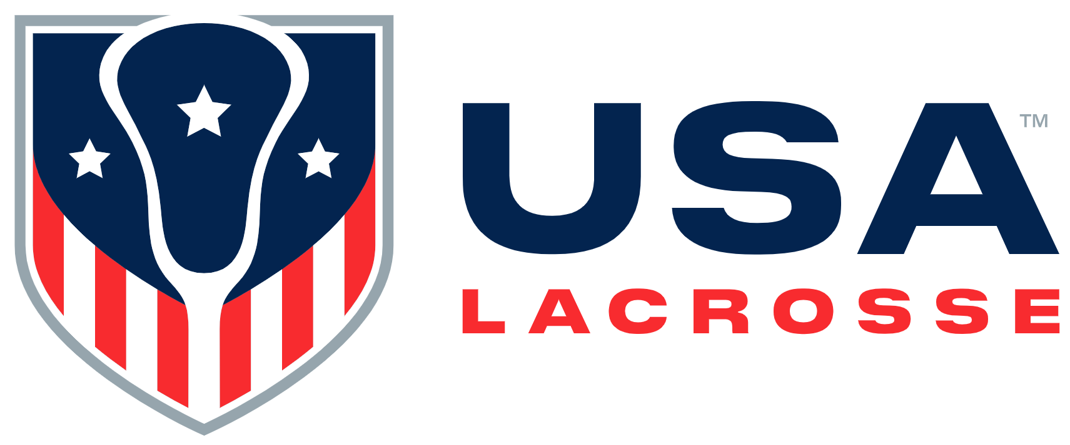

Board Meeting Minutes
Monday, February 12, 2024

Participants: Alex Cade, Kristen Carr, Jim Kanuch, Anna Kim, Andrew Lee, Andrea Lin, Darren Lowe, Beth Lyman, Juan-Pablo Mas, Sarah Bullard McDaniel, Shawn Nadelen, Mikko Red Arrow, Ann Rodriguez, Courtney Shute, Whitney Nye

Absent: Rick Burton, Jules Heningburg, Sarah Leary, Brandon Perkins

Staff participants: Cara Morris, Nancy Patrick, Marc Riccio, Jon Rodak, Kiernan Schindler, Brian Silcott, Karen Krupka Smith, Jason Vescovi and Ellen Zavian

Mr. Lee called the meeting to order at 11:02 a.m.

Welcome and Review of Agenda [A. Lee ]: Mr. Lee welcomed attendees and stated Native Americans across the country are celebrating the beginning of a new year. He shared the Seneca Thanksgiving Address in the native language.
- Consent Agenda [A. Lee]:
- 2024 Meeting/Event Schedule, Executive Committee Action, November 2023 Board meeting minutes: Mr. Kanuch moved to approve all Consent Agenda items; Ms. Lyman seconded the motion. The motion was approved.

- Finance [C. Morris]: Ms. Morris referenced the preliminary December 2023 consolidated balance sheet. The Finance Department is reconciling 2023 financials. The fiscal year audits will begin March 11th.
Ms. Morris referenced the pre-circulated approved 2023 Budget vs 2023 Forecast. USAL had a positive year-end balance. Ms. Morris anticipates additional savings for Q4 2023.
Ms. Morris stated the 2024 budget was built on positive trends. Ms. Morris will present any 2024 budget adjustments at the June 5th Board meeting in NYC.

- Executive Summary Updates: Mr. Riccio provided some additions to the pre-circulated Executive Summary:
  - Ronnie Morales, Director of Sport Growth and DEIO, started today.
  - Mr. Silcott, Ms. Kelley and Mr. Riccio were recently in Indianapolis to view USAL’s Fall Event location and meet with NFHS and NCAA representatives for two days. There were positive meetings on rules alignment, safety and equipment processes, and lacrosse growth strategies.
  - The combined USAL Magazine and USAL Brand site has pre-launched.
  - USAL has launched age verification as part of the member flow.

- Membership: Ms. Krupka Smith stated USAL’s 2024 budget goal for membership is 420,00 transactions. USAL will launch an SMS campaign soon in conjunction with an email journey regarding membership renewals.

- USAL Foundation: Mr. Rodak referenced the pre-circulated 2023 Foundation Review, highlighting there was a 65% increase in the $10K+ gift level.
- Commercial: Ms. Schindler stated USAL’s prospect pipeline has changed significantly in the past two years. The new mix of assets is important, as it will play into organizational events such as the Women’s Day USAL will host the day prior to the USA Lacrosse Experience event in Indianapolis in October. Discussion ensued regarding multi-year partnerships and gifts.

BREAK: There was a break from 11:43 – 11:54 a.m.

- 6 – 9 Year-Old Member Strategy [M. Riccio]: Mr. Riccio presented on a potential 2025 – 2026 strategy for growth in the 6 – 9 year old age bracket. Data shows six to nine year olds during 2020 – 2022 never picked up a stick, which has had a long term effect on USAL. This headwind is realized in many sports across the country. Data reflects that USAL had more seven year old players in 2023 than in the history of the organization.
Mr. Riccio stated YOY growth for an age cohort is consistent over the past ten years, after removing COVID effects. Discussion ensued regarding various potential strategies to increase lacrosse participation at the seven year old age. Continued discussion ensued regarding building out a financial model for additional investment in youth player acquisition and creating a campaign around it, and potential pilots and experimentation. subscriptions and the age those could occur, and local content generation.

- Lunch: There was a break from 12:48 – 1:01 p.m., followed by a working lunch.

- USOPC / NGB Strategy [M. Riccio]: Mr. Riccio stated USAL is a Recognized Sport Organization (RSO), which is one step down from a National Governing Body (NGB).
The USOPC sent an invitation to Mr. Riccio in mid-December to attend a mid-January USOPC meeting on how to become an NGB. Ms. Zavian, Dr. Vescovi and Mr. Riccio attended the meetings. After their return, Mr. Riccio received numerous calendar invitations to attend USOPC onboarding virtual meetings for CEOs over the next 8 – 12 weeks. If USAL becomes an NGB, it would shoulder the responsibilities of Safe Sport (athlete protection), financial support, audit and compliance. Mr. Riccio pre-circulated a summary of the pros and cons, and strategic benefits and challenges of moving from an RSO to an NGB.
Ms. Zavian stated Olympic attainment was the impetus for eight separate national lacrosse organizations to merge into US Lacrosse. USL formally began operations in January 1998 but there is a strategic plan document from 1992 outlining steps to become an NGB.

- Old Business
- Targeted Sponsorship Brands: Ms. Schindler addressed this topic earlier in the meeting.
- USAL Volunteer Structure Update: Ms. Patrick reviewed progress of the new national volunteer structure, noting the goal is to have all groups fully populated by August 1st.
Discussion ensued.

- New Business
- Outreach for Major Gifts: Mr. Lee stated the USAL Board has a key role in the cultivation of major gifts by identifying potential donors and thanking existing ones.
- 2024 USAL Foundation Gala: Mr. Rodak stated Cindy Timchal and Kevin Corrigan are the 2024 Gala Honorees. The Gala will be on June 5th at Gotham Hall in NYC. Discussion ensued regarding National Teams representation at the event.
- Governance Committee Update: Ms. Bullard McDaniel reminded Directors about the call for names request from the GC. There will be at least three upcoming Board vacancies. Ms. Bullard McDaniel shared areas of expertise priorities on which the GC is focused.

- Executive Session: Staff other than Mr. Riccio exited the meeting at 2:15 p.m.

- Adjourn: The meeting adjourned at 3:00 p.m.

The Board approved the following:
- The Consent Agenda Items

There will be a Board meeting at Jay Suites (1441 Broadway – Times Square) in New York City on Wednesday, June 5th. There will be a Zoom meeting option for those unable to attend in person.

