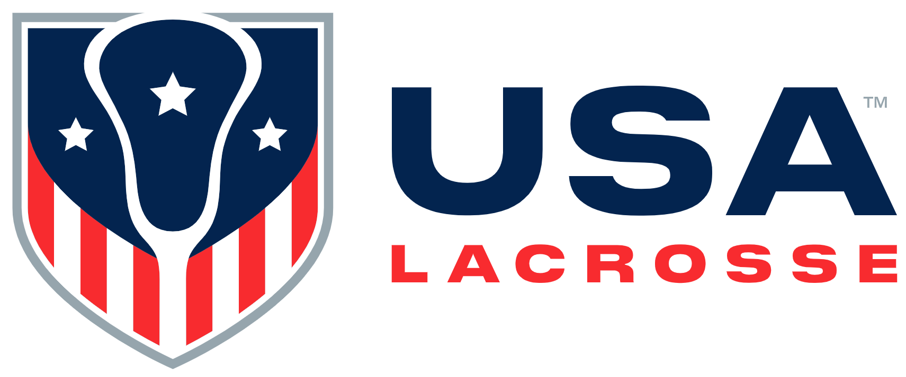

Board Meeting Minutes
Wednesday, June 7, 2023

Participants: Alex Cade, Kristen Carr, Tamara Floruss, Jim Kanuch, Anna Kim, Sarah Leary, Andrew Lee, Darren Lowe, Beth Lyman, Christianne Malone, Sarah Bullard McDaniel, Brandon Perkins, Ann Rodriguez, Courtney Shute

Absent: Cherie Greer Brown, Kevin Corrigan, Jules Heningberg, Darren Lowe, Mikko Red Arrow, Whitney Nye

Staff participants: Ann Carpenetti, Cara Morris, Nancy Patrick, Marc Riccio, Jon Rodak, Brian Silcott, Karen Krupka Smith and Ellen Zavian

Absent: Kiernan Schindler

Mr. Lee called the meeting to order at 12:30 p.m.

Welcome and Review of Agenda [A. Lee ]: Mr. Lee welcomed attendees and shared Ganö:nyök, a thanksgiving address, in the native Seneca language.
- Consent Agenda [A. Lee]:
- February and April Board Meeting Minutes, 2023 & 2024 Meeting Schedules, Executive Committee Action, Sports Science & Safety Committee Updates and Nominees, MARS Nominee: Mr. Kanuch moved to approve all Consent Agenda items; Ms. Malone seconded the motion. The motion was approved.

- Business Updates / Finance: Mr. Riccio stated staff would review financials and provide dashboard highlights. Staff would ask for Board discussion and feedback on membership strategy, which includes programming and audience segmentation. Coach Danowski would join the meeting virtually to provide an update on the Men’s World Championship at the end of June.
  - 2022 USAL / USALF Audit [J. Kanuch/C. Morris]: Mr. Kanuch stated the Finance Committee met with USAL’s auditing firm Elin & Tucker on June 2nd. The group reviewed the audited financial statements and the required communications letter. They gave USAL a clean opinion on the audit, which is the highest assurance an auditor can provide on financial statements. The auditors reviewed the communications letter, which reflects no difficulties occurred during the audit; there were no unusual transactions, no communications with other auditing firms, no contentious matters. They reviewed and accepted USAL’s financial policies and estimates.
Board for approval. She will circulate the Form 990 to the USAL and USALF Boards when it is complete.

  - Ms. Morris referenced the April Consolidated Balance Sheet. The major impact YOY is USAL was preparing for the 2022 WWC last year so there was considerably more cash due to other countries’ payments for the event. USAL has been trying to draw down its cash account as much as possible to minimize the concentration of risk with banking issues in the U.S. earlier this year. Investments are performing better but are still a bit low YOY.

Staff would provide highlights from the dashboards.

- 2023 Men’s National Team [J. Danowski]: Duke University and USA Men’s National Team (MNT) Head Coach John Danowski virtually joined the meeting at 1:10 p.m. He provided an update on current and upcoming MNT activity, challenges associated with the 2023 Men’s Championship, preparing MNT players to be role models and exemplars of sport and citizens, and on team captain selection.
BREAK: There was a break from 1:30 – 1:40 p.m.

- Membership Strategy Discussion [M. Riccio]: Mr. Riccio stated USAL is focused on redefining what is best for a USAL member experience. He addressed factors related to both mission and business, including growth in youth and high school membership and a fan member product.
Mr. Riccio stated USAL is due a membership price increase in terms of revenue opportunity and managing inflation. The last increase was in 2016. Discussion ensued about tangible membership benefits, specifically online content, and partners subsidizing that for USAL. Staff will develop testing to identify an additional member product.

- 2023 – 2024 USAL Board Slate [S. McDaniel/A. Lee]: Ms. McDaniel stated the Governance Committee was charged with identifying nominees to fill four upcoming Board positions and has put forth Rick Burton, Andrea Lin, Shawn Nadelen and Juan-Pablo Mas. Five current Board members have agreed to serve an additional term: Kristen Carr, Jim Kanuch, Anna Kim, Mikko Red Arrow and Ann Rodriguez. The Governance Committee has also proposed that Brandon Perkins fill the upcoming Executive Committee vacancy. Ms. Malone motioned to approved four new Board members, five returning Board members and Brandon Perkins’ move to the Executive Committee; Mr. Cade seconded the motion. The motion was approved.
  - Recognition of Outgoing Directors [A. Lee]: Mr. Lee recognized four Board members cycling off the Board: Cherie Greer Brown, Kevin Corrigan, Tamara Floruss and Christianne Malone.
  - 2022 Directors of The Year [M. Riccio]: Mr. Riccio stated each year staff votes on a USAL Director of the Year. There was a tie for the 2022 Director of the Year, and both those people are cycling off the Board: Tamara Floruss and Christianne Malone.
- New Business
- 2023 USALF Gala [J. Rodak]: Mr. Rodak thanked Board members for their support of the Gala. One goal is to encapsulate what US(A)L has done for players, coaches, families, grant recipients and the community at large for the past 25 years. Mr. Rodak stated there will be 400+ people in attendance. Seating arrangements have Board and staff members scattered throughout the room.
- USAL’s Conflict of Interest Form [E. Zavian]: Ms. Zavian stated shehas updated the form for future use. Ms. Patrick will circulate the updated document on August 1st to all Board members.

- Old Business: There were no Old Business items

- Executive Session: Staff other than Mr. Riccio exited the meeting at 3:15 p.m.

- Adjourn: The meeting adjourned at 4:00 p.m.

The Board approved the following:
- The February and April 2023 USAL Board meeting minutes
- The Sports Science & Safety bylaw amendment regarding leadership succession
- Nominations of Dr. Catherine Logan and Dr. Eugene Chung to the Sports Science & Safety Committee
- Nomination of Kelly Jones-Swenson to chair the Misconduct Appeals Review Subcommittee
- Nominations of Rick Burton, Andrea Lin, Juan-Pablo Mas and Shawn Nadelen to serve on the USAL Board as of August 1, 2023
- Nominations of Kristen Carr, Jim Kanuch, Anna Kim and Ann Rodriguez to serve another two-year term and Mikko Red Arrow to serve his first full two-year term
- Nomination of Brandon Perkins to begin Executive Committee service

There will be a USAL Board dinner on Sunday, November 5th in the Hunt Valley, MD area and an in-person Board meeting at USAL HQ on Monday, November 6th.

