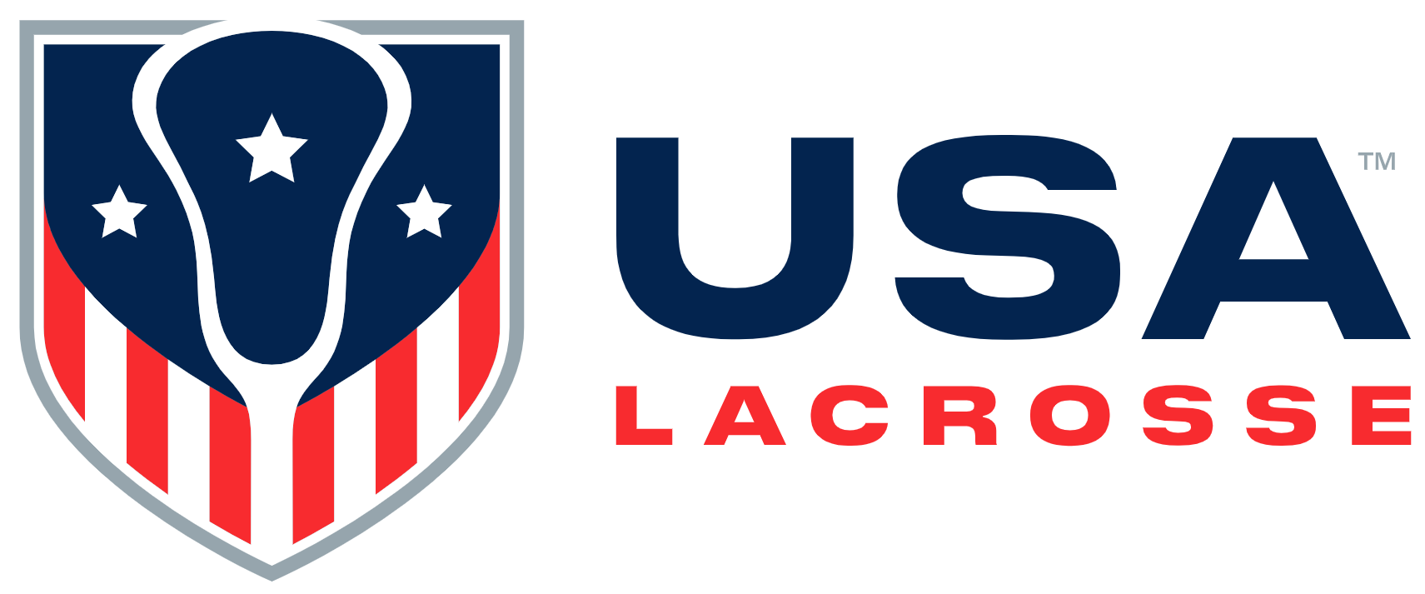

Board Meeting Minutes
Wednesday, June 5, 2024

Participants: Alex Cade, Kristen Carr, Jim Kanuch, Andrew Lee, Andrea Lin, Darren Lowe, Beth Lyman, Juan-Pablo Mas, Sarah Bullard McDaniel, Shawn Nadelen, Mikko Red Arrow, Ann Rodriguez, Courtney Shute and Whitney Nye

Staff participants: Dwane Morgan Cara Morris, Marc Riccio, Brian Silcott, Karen Krupka Smith, Jason Vescovi and Ellen Zavian

Absent: Anna Kim, Brandon Perkins and Nancy Patrick

Mr. Lee called the meeting to order at 12:30 p.m.

Welcome and Review of Agenda [A. Lee]: Mr. Lee welcomed attendees and shared a story of the first time he played lacrosse, and how the sense of community, feeling and transformational experience is what the sport of lacrosse is all about. He stated the meeting would begin with the Consent Agenda, followed by discussion on trends, organizational business, youth lacrosse balls and equipment, homage to those directors finishing their time of Board service, and voting on the 2024-2025 Board slate.

Mr. Riccio introduced Dwane Morgan, Chief of Staff and Business Intelligence. He stated Caitlyn Kelly, Senior Director of Sports Administration, would join the meeting during the youth ball discussion.

- Consent Agenda [A. Lee]:
- February Board Meeting Minutes, 2023 & 2024 Meeting Schedules, and Executive Committee Action: Mr. Mas moved to approve all Consent Agenda items; Ms. Carr seconded the motion. The motion was approved.

- Trends / Self Scouting [M. Riccio]: Mr. Riccio referenced the macro market trends, noting that the following occur in real time: private equity in youth sports; continued change in college athletics and how that will affect the sport of lacrosse and USAL; and how USAL can become more active in policy decisions on the potential government support of youth sports. There is significant change in the marketplace that affects sports as whole. Youth participation in sports continues on a positive trend.
Mr. Riccio stated USAL recently hired a VP of Sponsorships and Partnerships. The search for a VP of Fundraising is ongoing.
Mr. Riccio stated more there are more under-9 players than ever before in the history of lacrosse. USAL is net positive coming out of COVID and return-to-play has occurred in all categories.

- National Governing Body (NGB) Application Update / Discussion [M. Riccio]: Mr. Riccio reported on the move toward obtaining NGB status. Mr. Riccio stated USAL continues to work with the NCAA and NFHS on rule setting and equipment standards and safety.

- Finance [J. Kanuch / C. Morris]:
- 2023 USAL / USALF Audit: Mr. Kanuch stated the Audit Subcommittee met on May 15th to review the 2023 FYE audit. The auditors had a clean opinion, and there were no significant deficiencies or material weaknesses noted. Reconciliation timeliness was an issue, but this was due to a new software transition.
Ms. Morris stated USAL’s income statement reflects USAL is financially sound through April 30, 2024. Discussion ensued regarding USAL’s contract with MedStar and the decrease in sport growth spending.

- Business Dashboard Discussion [All]:
  - Membership [K. Krupka Smith]: Ms. Smith stated USAL had 427,000 members on May 31, 2024. At this time, USAL has 1834 signed member organization agreements. Mr. Riccio stated age verification has been a success.
  - Foundation / Gala [M. Riccio]: Mr. Riccio stated the Gala team is meeting its goals.
  - Commercial [M. Riccio]: Mr. Riccio stated sponsor and partner renewals have been a challenge with endemic entities. One focus is to grow the non-endemic area.

- Youth Ball Standard Strategy Discussion [M. Riccio]: Mr. Riccio introduced Ms. Kelley, who referenced submitted slides, outlining the existing pathway to create a standard. She discussed two different concerns that USAL is looking to address through a change to the ball standard. First for female players, recent headgear studies demonstrated the injurious nature of ball impact. Concurrently, looking at the goals to grow the game in conjunction with anecdotal feedback on the ball hurting and being a deterrent, USAL reviewed the ball standard as a potential means to enhance the younger player experience. Ms. Kelley pointed out that lacrosse is an outlier from other sports with no standard on the ball, nor does it have a gender specific ball or a youth ball. USAL collaborated with Guardian Pear to assess specifications and options to reduce impact forces of the ball without adversely impacting the athlete experience. USAL has had discussions with the National Operating Committee on Standards for Athletic Equipment (NOCSAE) on new standards. Additional information should be available after the NOCSAE meeting in July 2024.
A new standard project would take about 18 months. Discussion ensued.

- 2024 – 2025 USAL Board Slate [S. McDaniel/A. Lee]: Ms. McDaniel thanked the Governance Committee (GC) for identifying nominees to fill four upcoming Board positions. She referenced the pre-circulated slides and stated Tim Corrigan, Fielding Kidd Jamieson, Jennifer Russell and Gina Oliver Thomas are the four new nominees. In addition, the GC recommends second term renewals for Alex Cade, Whitney Nye and Brandon Perkins. Lastly, the GC proposed Andrea Lin fill an Executive Committee vacancy and that Darren Lowe serve as Vice Chair.
Mr. Kanuch moved to approve four new Board members, second terms for three Board members, Andrea Lin’s move to the Executive Committee, and Darren Lowe’s nomination to serve as Vice Chair; Mr. Mas seconded the motion. The motion was approved.
  - Recognition of Outgoing Directors [A. Lee]: Mr. Lee recognized Jules Heningburg, Sarah Leary and Courtney Farrell Shute for their years of Board service. He also spoke about Ms. Lyman’s six years of Board Leadership service. Mr. Lee provided a list of comments on each person.
  - 2023 Director of The Year [M. Riccio]: Mr. Riccio stated each year staff votes on a USAL Director of the Year. He read a long list of staff comments about a specific Board member and announced Darren Lowe as the 2023 Director of The Year.
  - Committee / Subcommittee / Task Force Members [E. Zavian]: Ms. Lyman moved to approve the pre-circulated national volunteer nominees; Ms. Shute seconded the motion. The motion was approved.

- Old Business: There were no Old Business items

- New Business: There were no New Business items.

- Executive Session: Staff other than Mr. Riccio exited the meeting at 3:30 p.m.

- Adjourn: The meeting adjourned at 4:00 p.m.

The Board approved the following:
- The February 2024 USAL Board meeting minutes
- Approved the Governance Committee’s proposed 2024 – 2025 USAL Board slate:
- Darren Lowe, Vice Chair
- Andrea Lin to serve on the Executive Committee
- Tim Corrigan
- Fielding Kidd Jamieson
- Jennifer Russell
- Gina Oliver Thomas, IWLCA Board representative

There will be a USAL Board dinner on Sunday, November 3rd in the Hunt Valley, MD area and an in-person Board meeting at USAL HQ on Monday, November 4th.

