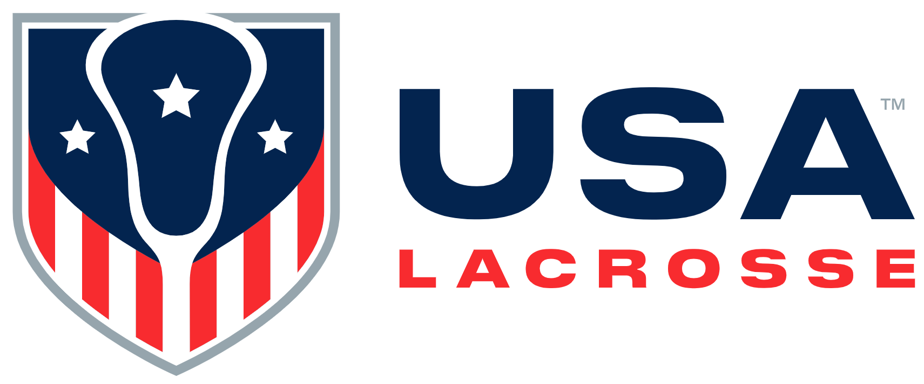

Board Meeting Minutes
Monday, November 6, 2023

Participants: Rick Burton, Alex Cade, Kristen Carr, Jules Heningburg, Jim Kanuch, Anna Kim, Sarah Leary, Andrew Lee, Andrea Lin, Darren Lowe, Beth Lyman, Juan-Pablo Mas, Sarah Bullard McDaniel, Shawn Nadelen, Brandon Perkins, Mikko Red Arrow, Ann Rodriguez, Courtney Shute, Whitney Nye

Staff participants: Cara Morris, Nancy Patrick, Marc Riccio, Jon Rodak, Kiernan Schindler, Brian Silcott, Karen Krupka Smith, Jason Vescovi and Ellen Zavian

Mr. Lee called the meeting to order at 10:03 a.m.

Welcome and Review of Agenda [A. Lee ]: Mr. Lee welcomed attendees. He shared the Haudenosaunee story of the first game of lacrosse. Mr. Lee welcomed new Board members and asked them to speak a few words about themselves.

- Consent Agenda [A. Lee]:
- 2024 Meeting/Event Schedule, Executive Committee Action, June Board meeting minutes, USAL Revised National Volunteer Structure and the USAL Bylaw Amendment Proposal: Ms. Lyman moved to approve all Consent Agenda items; Ms. Kim seconded the motion. The motion was approved.

Mr. Riccio provided an LA2028 update. The Leadership Council USAL established earlier in the year (Athletes Unlimited, the PLL and NLL, the IWLCA and IMLCA, World Lacrosse and J Tsai Sports), is focused on doubling lacrosse participation, which is part of USAL’s Long Range Plan (LRP). The group decided to announce its own initiative immediately following the LA2028 announcement. Hence, the birth of ELEVATE28, which is a platform that the eight organizations could ladder up into. Discussion ensued regarding the recent NYSE event during which Mr. Riccio rang the closing bell and navigating stakeholders in lacrosse around LA2028.

- Finance:
  - 2023 Review / Update [M. Riccio/C. Morris]: Ms. Morris and Mr. Riccio shared a few slides on the key measurables of:
- Membership – Historical data from USAL’s peak year of 2015 to the current year. Prior to 2015, membership skyrocketed. COVID 19 adversely affected membership, although USAL fared better than some other youth sports.
- The USAL Foundation – The trends include annual giving and a highly successful Capital Campaign for the current HQ. There has been an upward trajectory since the COVID 19-related drop.
- Partnerships/Sponsorships – There was an upward trend from 2015 – 2019; a dip during the pandemic; and an upward return since 2020.
- Revenue and Revenue Per Employee: USAL is looking at employee efficiencies and yield. The organization should be able to grow its revenue without increasing its staff.
- Revenues and Expenses – USAL is analyzing salary and benefits expenses vs. revenues.
Ms. Morris reviewed USAL’s 2023 Q3 financials. The organization reports on a consolidated basis. It has three organizations: USA Lacrosse, the USA Lacrosse Foundation, and the USA Lacrosse Center, LLC (the building and land on which it sits). The LLC has one member: the USAL Foundation. Therefore, the USALF and LLC financials are consolidated. The USAL and USALF financials are consolidated because the Operating Board has decision making over who is approved to sit on the USAL Foundation Board. However, USAL and the USALF file taxes as separate entities.
Ms. Morris reviewed the 2023 financial budget vs. the 2023 forecast. USAL introduced an incentive program in 2022. Additionally, it budgeted a 2-3% COLA increase for the 2024 budget.
  - Proposed 2024 Operating Budget and Business Plans: Covered later in meeting

- Olympic Update [M. Riccio]: Mr. Riccio introduced Dr. Vescovi, Director of Sports Science. Dr. Vescovi reported on USAL’s focus on evolving National Team player talent identification and a talent identification model. He reported on the physical demands of the sport and the technology USAL is using to analyze those.

BREAK: There was a break from 11:43 – 11:54 a.m.

- Business:
  - New Member Pricing / Experience [K. Krupka Smith]: Ms. Smith referenced the pre-circulated dashboard numbers. Discussion ensued regarding insight and analytics.

- Lunch: 12:08 – 12:30 p.m.

- Sport Growth Programming [B. Silcott]: Mr. Silcott reviewed the pre-circulated coach and official development programs and learning pathways. In addition to online courses, USAL will have coaches’ academies across all regions and will add virtual academies. Outside the certification process, USAL will build course tracks. Discussion ensued regarding providing different levels to coaches and potential incentives, and sport growth initiatives falling under the ELEVATE28 banner. Mr. Riccio stated the ELEVATE28 group is locked in on two key metrics: the participation number and the pathway to that. Discussion ensued.
Mr. Silcott stated USAL will term its clinics “Pick Up & Play”. This will include NCLW and Sankofa, among others. This play leads into Flex6 and then to Sixes.

USAL Foundation [J. Riccio]: The Foundation is focused on the “It Starts with A Stick” campaign for its annual giving. It comes off the heels of the LA2028 and ELEVATE28 announcements. ELEVATE28 shows there is unification in the sport. Mr. Rodak shared success stories that resonate the journey of the sport starts with a stick. The Foundation team will focus on enticing people to pay if forward, stressing how every $28 donation is an opportunity investment. This number mirrors LA2028 and ELEVATE28.
USAL’s 2024 grant vision includes several changes. Ms. Morgan, Grant Manager, moved from Sport Development to the Foundation earlier in 2023. USAL impacted 1,400 youth players in 2023. The team reassessed its grant program. Ms. Morgan will explore adding an online equipment store that will have a co-branded, partnered grant for 2025 and beyond. Programs can purchase add-ons. The 2024 budget will award up to 50 PE grants (Lacrosse unBoxed) to elementary and middle schools and education grants for some USAL academy offerings.

Mr. Riccio asked for a vote on the proposed budget. Mr. Lowe moved to approve the 2024 Operating Budget; Ms. Leary seconded the motion. The motion was approved.

- New Business
  - USAL Bylaw Amendment Proposal: Addressed under the consent Agenda.

- Executive Session: Staff other than Mr. Riccio exited the meeting at 3:15 p.m.

- Adjourn: The meeting adjourned at 4:00 p.m.

The Board approved the following:
- The Consent Agenda Items
- The updated USAL national volunteer structure
- The proposed USAL bylaw amendments
- The 2024 Operating Budget

There will be a hybrid meeting (USAL Headquarters and Zoom meeting options) on Monday, February 12, 2024 from 11:00 a.m., ET – 3:00 p.m., ET.

