# 

**Avon Grove Lacrosse**

**Emergency Action Plan**

| **COACHES ARE MANDATORY REPORTERS OF CHILD ABUSE**  If you suspect any instance of child abuse, immediately contact PA Childline at 1-800-932-0313 and contact a board member immediately. |
| --- |

## 

# 

# Emergency Quick Reference

The following is a quick reference guide for steps to be taken during various types of emergencies. Prior to the start of the season please review and become familiar with this entire Emergency Action Plan (EAP) as it contains additional details regarding each emergency.

| **UNCONSCIOUSNESS / SUDDEN CARDIAC ARREST**   * Suspend all play immediately. * Send all players off the field to their appropriate team bench * Shake the person by the shoulders and speak loudly to them in an attempt to get them to respond * **Call 9-1-1** as soon as you suspect a sudden cardiac arrest - i.e. the heart has stopped * Begin CPR right away by pushing hard and fast on the center of the person’s chest 100-120 times per minute. * Have a second person get an AED or get it yourself after 2 minutes of CPR. * Open up and/or turn on the unit and follow the device voice directions to apply pads to the person. * Follow all instructions from the AED. * Contact the player’s parents/guardian. If providing care, have another coach or adult contact the parents/guardian. * Instruct a coach or a parent wait at the entrance of the field you are on for Emergency Medical Services (EMS). * Transfer the person to EMS at their request. * Allow EMS or the person’s hospital care team access to the AED to get data from the device about the cardiac arrest. This can usually be done without having to give the AED to anyone, so continue to keep the AED with you for all practices / games. * EAP coordinator will replace the AED electrode pads immediately following the use of the AED. |
| --- |

## 

| **HEAD TRAUMA / SUSPECTED CONCUSSION**   * Suspend all play immediately. * If mobile, immediately remove the player from the field. **Players are not permitted to return to play under any circumstances.** * If loss of consciousness is **suspected**, immediately contact 9-1-1 and follow all directions * If a neck injury is suspected or there is loss of mobility or sensation anywhere on the body, **do not move the player or remove equipment.** Immediately contact 9-1-1. * Contact the player’s parents/guardian. If providing care, have another coach or adult contact the parents/guardian. * Instruct a coach or a parent wait at the entrance of the field you are on for Emergency Medical Services (EMS). * **After a head trauma or suspected concussion, players may not return to play without written clearance from a medical professional.** |
| --- |

| **NECK INJURY / PARALYSIS**   * Suspend all play immediately. * **Do not move the player or remove equipment.** Immediately contact 9-1-1 and follow all directions. * Instruct a coach or a parent wait at the entrance of the field you are on for Emergency Medical Services (EMS). * Contact the player’s parents/guardian. If providing care, have another coach or adult contact the parents/guardian. |
| --- |

| **FRACTURED BONE**   * Suspend all play immediately. * If fracture is severe or compound (bone protruding from the skin), immediately contact 9-1-1 and follow all directions * If possible, remove the player from the field. **Do not attempt to stabilize or splint the fracture.** * Instruct a coach or a parent wait at the entrance of the field you are on for Emergency Medical Services (EMS). * Contact the player’s parents/guardian. If providing care, have another coach or adult contact the parents/guardian. |
| --- |

| **CHOKING**   * Immediately perform abdominal thrust (Heimlich Maneuver)   + Stand behind the person. Place one foot slightly in front of the other for balance   + Wrap your arms around the waist. Tip the person forward slightly. If a child is choking, kneel-down behind the child.   + Make a fist with one hand. Position it slightly above the person’s navel.   + Grash the fist with the other hand. Press hard into the abdomen with a quick, upward thrust, as if trying to lift the person up.   + Performance abdominal thrusts until the blockage is dislodged or the person goes unconscious.   + If the person becomes unconscious, immediately perform CPR. * Immediately contact 9-1-1 and follow all instructions. * Instruct a coach or a parent wait at the entrance of the field you are on for Emergency Medical Services (EMS). * Contact the player’s parents/guardian. If providing care, have another coach or adult contact the parents/guardian. |
| --- |

| **BLEEDING**   * Prior to treating any bleeding injury put on gloves. * Apply bandages as appropriate and apply direct pressure. * If bleeding is severe or cannot be controlled, immediately contact 9-1-1 and follow all instructions. * Instruct a coach or a parent wait at the entrance of the field you are on for Emergency Medical Services (EMS). * Contact the player’s parents/guardian. If providing care, have another coach or adult contact the parents/guardian. |
| --- |

# 

# Coach Responsibilities

Coaches are responsible for maintaining the safety and security of players at all times during practices and games. Coaches should have with them at all times:

* Emergency Action Plan (EAP)
* Medical Kit
* Automated External Defibrillator (AED)
* Cell Phone with TeamSnap app installed

# Medical Kit Inventory

The primary medical kit to be used is the issued AGL MFASCO First Aid bag. Kits will be checked by the medical coordinator at the beginning of each season and refilled as necessary. The bag is divided into three sections:

* Front Zipper Pocket - Personal protection (gloves) and cleaning / antiseptic
* Middle Zipper Pocket - Bandages, tools/scissors, extra mouthguards
* Large Pocket - Large bandages, ice packs, compression wraps

**When dealing with any bodily fluids of any sort, always put on gloves or, if a minor cut or scrape, have the players put on bandages themselves.** Be sure to properly dispose of gloves, bandages, or any other contaminated items.

If medical supplies need to be re-ordered during the season, please contact the Emergency Action Plan Coordinator, Bryan Inagaki ([bryan.inagaki@avongrovelacrosse.org](mailto:bryan.inagaki@avongrovelacrosse.org)). Below is a full list of medical supplies in each bag:

**Front Zipper Pocket**

* Antiseptic Kit
* Antimicrobial Wipes Pack
* First Aid Pocket Guide
* Nitrile Gloves Pair x 3

**Middle Zipper Pocket**

* Adhesive Bandages Kit
* Gauze Kit
* Moleskin 2” Patch
* Mouthguards
* Screwdriver
* Utility Shears

**Large Zipper Pocket**

* Athletic Tape - 1 ½” x 2
* Cold Pack Jr x 5
* Cold Pack Jr x 5
* Cohesive Bandage - 2” Roll
* Cohesive Bandage - 3” Roll
* Elastic Bandage with Clips - 3” Roll
* Gauze Roll - 2”
* Gauze Roll - 3”
* Nosebleed Plugs
* Mueller M Wrap - 2 ¾” x 2
* Triangular Bandage - 40”

# Inclement Weather

In the case of inclement weather, coaches have discretion regarding the need to cancel practices or games. In the event of thunder or lightning, the following guidelines apply:

* Play must be immediately suspended and players must take shelter if thunder is heard or lightning is observed.
* Play can be resumed once no thunder is heard or lightning is visible after **30 minutes**. If thunder / lightning is observed at any point, play must be suspended for an additional **30 minutes.**

# 

# Medical Emergencies

Coaches must take extreme care when there is any type of medical emergency to protect the safety of our players. For all medical emergencies, the following guidelines apply:

* Coaches must protect themselves and players from transmission of diseases and bloodborne pathogens. The first step to be taken when responding to any medical emergency is to put on gloves provided in the medical kits.
* The player must be attended at all times by a coach, parent/guardian, or medical professional.
* If transport to a medical facility is required and a parent/guardian is not available, an AGL coach must accompany the player.
* After any medical incident, complete an AGL Incident Report and submit to the Board of Directors. The EAP coordinator will schedule a discussion of the emergency with the coaching staff and board of directors to review response performance and the overall emergency response protocol.

## Unconscious Athlete / Sudden Cardiac Arrest

**Signs of sudden cardiac arrest can include one or more of the following:**

* Not moving, unresponsive, or unconscious.
* Not breathing normally (i.e. may have irregular breathing, gasping, gurgling, or may not be breathing at all).
* Seizure or convulsion-like shaking activity

| **Steps DURING an unconscious athlete / sudden cardiac arrest emergency**   * Suspend all play immediately. * Send all players off the field to their appropriate team bench * Shake the person by the shoulders and speak loudly to them in an attempt to get them to respond * **Call 9-1-1** as soon as you suspect a sudden cardiac arrest - i.e. the heart has stopped * Begin CPR right away by pushing hard and fast on the center of the person’s chest 100-120 times per minute. * Have a second person get an AED or get it yourself after 2 minutes of CPR. * Open up and/or turn on the unit and follow the device voice directions to apply pads to the person. * Follow all instructions from the AED. * Contact the player’s parents/guardian. If providing care, have another coach or adult contact the parents/guardian. * Instruct a coach or a parent wait at the entrance of the field you are on for Emergency Medical Services (EMS). * Transfer the person to EMS at their request. * Allow EMS or the person’s hospital care team access to the AED to get data from the device about the cardiac arrest. This can usually be done without having to give the AED to anyone, so continue to keep the AED with you for all practices / games. * EAP coordinator will replace the AED electrode pads immediately following the use of the AED. |
| --- |

## 

## Head Trauma / Suspected Concussion

**Athletes who experience a concussion may exhibit the following sign:**

* Appear dazed or stunned
* Get confused about what they are supposed to be doing on the field
* Forget plays
* Look unsure of the game, score, or opponent
* Move clumsily or appears off-balance / dizzy
* Be slow to answer questions
* Lose consciousness (only occurs in about 10-15% of concussions)
* Experience behavior or personality changes
* Be unable to remember events prior to or after the injury

**Athletes who experience a concussion may report the following symptoms:**

* Headache
* Nausea
* Balance problems or dizziness
* Double or fuzzy vision
* Sensitivity to light
* Sensitivity to noise
* Feeling sluggish
* Feeling mentally foggy
* Difficult concentrating
* Difficulty remember plays
* Confused about what play it is or what part of the game it is

For more information about concussions, please visit: https://www.chop.edu/concussions-field#

| **Steps DURING a head trauma / suspected concussion emergency**   * Suspend all play immediately. * If mobile, immediately remove the player from the field. **Players are not permitted to return to play under any circumstances.** * If loss of consciousness is **suspected**, immediately contact 9-1-1 and follow all directions * If a neck injury is suspected or there is loss of mobility or sensation anywhere on the body, **do not move the player or remove equipment.** Immediately contact 9-1-1. * Contact the player’s parents/guardian. If providing care, have another coach or adult contact the parents/guardian. * Instruct a coach or a parent wait at the entrance of the field you are on for Emergency Medical Services (EMS). * **After a head trauma or suspected concussion, players may not return to play without written clearance from a medical professional.** |
| --- |

## Neck Injury / Paralysis

| **Steps DURING a neck injury / paralysis emergency**   * Suspend all play immediately. * **Do not move the player or remove equipment.** Immediately contact 9-1-1 and follow all directions. * Instruct a coach or a parent wait at the entrance of the field you are on for Emergency Medical Services (EMS). * Contact the player’s parents/guardian. If providing care, have another coach or adult contact the parents/guardian. |
| --- |

## 

## Fractured Bone

| **Steps DURING a fractured bone emergency**   * Suspend all play immediately. * If fracture is severe or compound (bone protruding from the skin), immediately contact 9-1-1 and follow all directions * If possible, remove the player from the field. **Do not attempt to stabilize or splint the fracture.** * Instruct a coach or a parent wait at the entrance of the field you are on for Emergency Medical Services (EMS). * Contact the player’s parents/guardian. If providing care, have another coach or adult contact the parents/guardian. |
| --- |

## Choking

The universal sign for choking is hands clutched to the throat. If the person doesn’t give the signal, look for these indications:

* Inability to talk
* Difficulty breathing or noisy breathing
* Squeaky sounds when trying to breathe
* Cough, which may be weak or forceful
* Loss of consciousness

| **Steps DURING a choking emergency**   * Immediately perform abdominal thrust (Heimlich Maneuver)   + Stand behind the person. Place one foot slightly in front of the other for balance   + Wrap your arms around the waist. Tip the person forward slightly. If a child is choking, kneel-down behind the child.   + Make a fist with one hand. Position it slightly above the person’s navel.   + Grash the fist with the other hand. Press hard into the abdomen with a quick, upward thrust, as if trying to lift the person up.   + Performance abdominal thrusts until the blockage is dislodged or the person goes unconscious.   + If the person becomes unconscious, immediately perform CPR. * Immediately contact 9-1-1 and follow all instructions. * Instruct a coach or a parent wait at the entrance of the field you are on for Emergency Medical Services (EMS). * Contact the player’s parents/guardian. If providing care, have another coach or adult contact the parents/guardian. |
| --- |

## Bleeding

| **Steps DURING a choking emergency**   * Prior to treating any bleeding injury put on gloves. * Apply bandages as appropriate and apply direct pressure. * If bleeding is severe or cannot be controlled, immediately contact 9-1-1 and follow all instructions. * Instruct a coach or a parent wait at the entrance of the field you are on for Emergency Medical Services (EMS). * Contact the player’s parents/guardian. If providing care, have another coach or adult contact the parents/guardian. |
| --- |

# Field Information / Emergency Vehicle Directions

## Avon Grove High School

257 State Rd.

West Grove, PA 19390

**Emergency Vehicle Directions - Stadium**

* From State Road, enter the parking adjacent to the stadium.
* Immediate access by foot through the **MAIN GATE**
* For vehicle access, proceed down the access road to the **RIGHT** of the stadium and make the first **LEFT** and proceed down the access road.
* Entrance to the field is on the **LEFT**.

**Emergency Vehicle Directions - Turf Fields**

* From State Road, enter the parking adjacent to the stadium.
* Proceed down the access road to the **RIGHT** of the stadium and make the first **LEFT** and proceed down the access road.
* Entrance to the turf fields is on the **RIGHT**.

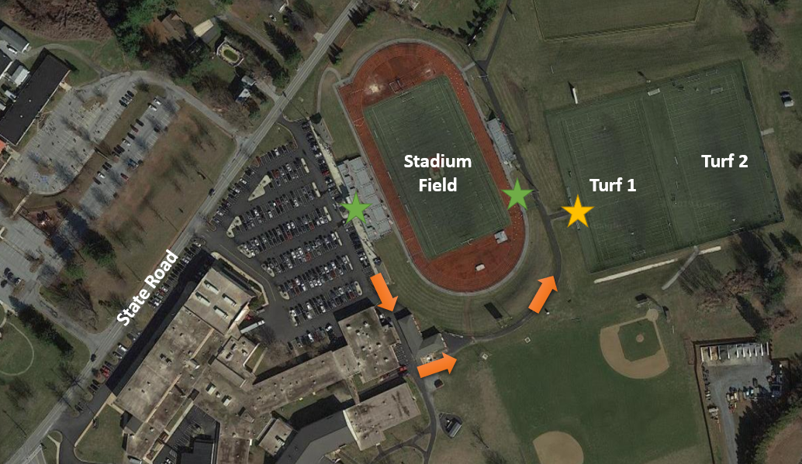

## Harmony Park

230 West Harmony Rd.

West Grove, PA 19390

**Emergency Vehicle Directions**

* From Old Baltimore Pike / West Evergreen Rd., turn **NORTH** on North Guernsey Rd.
* Turn **RIGHT** onto West Harmony Rd.
* Turn **RIGHT** into the park entrance.
* The upper field is to the **LEFT** behind the concession building, and the lower field is on the **RIGHT** behind the storage shed.

# 

# Emergency Contacts

**Emergency Medical Services: 9-1-1**

## Avon Grove Lacrosse Contacts

**Emergency Action Plan Coordinator:** Bryan Inagaki - 410-206-3870

**AGL President:** Mike McGinn - 610-563-4523

**AGL Secretary:** Kristin Lucovich - 610-368-9640

**AGL Treasurer:** Bryan Inagaki - 410-206-3870

**AGL Board Members:**

* Rick Firth - 610-425-0972
* Keith Jacoby - 610-299-6871
* Curt McCray - 610-637-3017
* Justin Sabol - 267-640-1497

## Medical Facilities

**CHOP Primary Care, West Grove**

455 West Woodview Rd.

West Grove, PA 19390

610-869-4700

**Chester County Hospital**

701 E. Marshall St.

West Chester, PA 19380

610-431-5000

**Nemours Children’s Hospital**

1600 Rockland Rd

Wilmington, DE 19803

302-651-4200

**Christiana Hospital**

4755 Ogletown Stanton Rd.

Newark, DE 19718

302-733-1000